# Ideation Phase

**Define the Problem Statements**

|  |  |
| --- | --- |
| Date | 23 November 2022 |
| Team ID | PNT2022TMID17180 |
| Project Name | Intelligent Vehicle Damage Assessment and  Cost Estimator for Insurance Companies |
| Maximum Marks | 2 Marks |

**Customer Problem Statement Template:**

Create a problem statement to understand your customer's point of view. The Customer Problem Statement template helps you focus on what matters to create experiences people will love.

A well-articulated customer problem statement allows you and your team to find the ideal solution for the challenges your customers face. Throughout the process, you’ll also be able to empathize with your customers, which helps you better understand how they perceive your product or service.

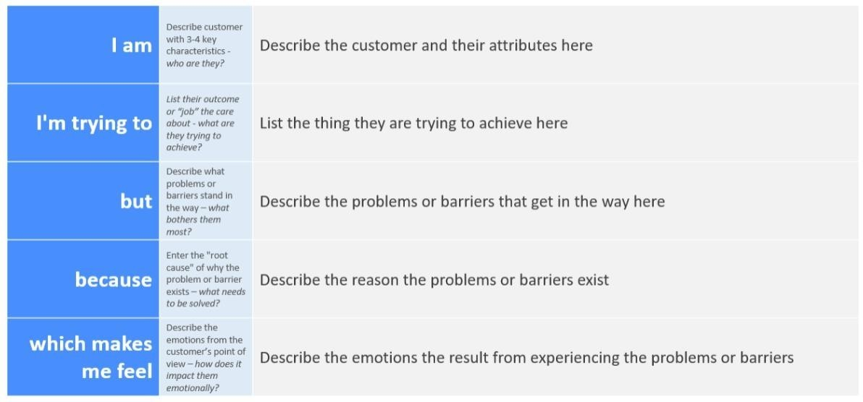

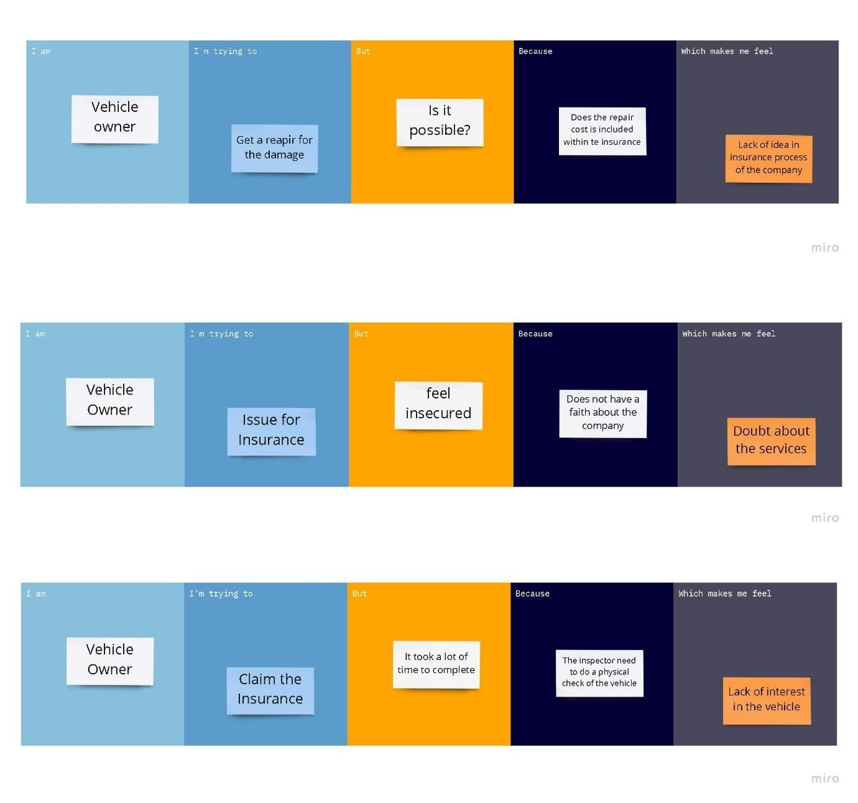

|  |  |  |  |  |  |
| --- | --- | --- | --- | --- | --- |
| **Problem**  **Statement (PS)** | **I am**  **(Customer)** | **I’m trying to** | **But** | **Because** | **Which makes me feel** |
| PS-1 | Vehicle owner | Get repair for the damage | Is it possible? | Does the repair cost is included within the  insurance | Lack of idea in insurance process of the company |
| PS-2 | Vehicle Owner | Issue for the insurance | Feel insecured | Does not have a faith about the  company | Doubt about the services |
| PS-3 | Vehicle Owner | Claim the insurance | It took a lot of time to complete | The inspector need to do a physical check of the  vehicle | Lack of interest in repairing the vehicle |